Lab 4: Introduction to LabVIEW

EG-UY 1003 Y1B

Jason Yao

Team members: Alice (Nanda) Ross, Jeremiah Nofrada

Date of experiment: 16th July 2015

Date due: 19th July 2015

**Abstract**

The objective of this lab was to design three digital systems by utilizing the LabVIEW programming software. These three systems included a simple calculator, a lighting control system for a building, and a thermal control system. The three digital systems were successfully built, and put through a test run on a circuit board to ensure it ran correctly. This lab was significant because it demonstrated the capability of utilizing simulated instruments in a laboratory, instead of physical instruments. Instead of having 30 plus specific physical instruments, all you’d need would be the computer to model these instruments, allowing for much faster iteration when prototyping. The lab also introduced basic programming concepts that will be used in future labs.

**Introduction**

In this lab, three digital systems were provided by the TAs, to be graphically modeled using the LabVIEW programming software. These systems would be tested for functionality, and usability in hardware tests.

In this lab, a specified robot design was provided by the TAs, to be assembled using the EV3 LEGO Mindstorms robotics kit. This robot was tested for accuracy and precision by evaluating the deviance from a standard, which was set before testing. Accuracy, defined by the EG Lab manual (2015), as “the degree required [to] allow results to be verified”, is a very important measurement when dealing with mission critical or safety issues. Precision, defined by the EG Lab manual (2015) as “the repeatability of a result, or how close the results are to each other”, is also a very important metric in industry and engineering. The robot would undergo tests for both accuracy and precision with a distance test and an angle of deviation test.

After the test results were collated, the robot was to be reverse engineered, analyzed, and then altered to try and improve the accuracy and precision of the robot. This modified design was to then be tested in the same fashion as the original robot, before being compared with the original to see which model would make it into production.

This lab’s goal was to thus identify underlying engineering concepts via reverse engineering, and to design a different robot utilizing those engineering concepts as design axioms. Hardware reverse engineering, defined by the EG Lab Manual as “taking apart a device to see how it works”, was the guiding axiom in this lab, so that the design of the original robot could be understood, allowing for a new design based off of the old one that could feature improvements.

sd

**Procedures**

A LEGO Mindstorms kit, a computer with Mindstorms software on it, a protractor, metre stick, graph paper, and a LEGO robotics kit were used to build the original robot and implement the testing phase.

Firstly, the robot was assembled in accordance with the instructions provided by the TAs. Unfortunately, due to technical difficulties with the email server, EG Lab Manual website, and projectors, the lab began late and progressed slowly. However, the robot was completed as per the specifications provided, and so the programming phase then began.

After assembly, the car was programed via the Mindstorms software in the lab computers, allowing digital logic to be placed in the memory of the robot that caused it to move for five seconds, before coming to a stop.

In the testing phase, the robot vehicle was placed on a piece of graph paper, before initiating the test program that would cause it to move. After the robot had come to a stop, a metre stick was used to draw a line between the robot’s start and stopping point. The robot did not move, however, and so it was disassembled and reassembled via a new design meant to make the car work. This was tested twice, before running out of time.

**Data/Observations**

The original robot design did not function due to the gears connecting to the wheels not properly meshing together. This resulted in a situation in which the robot sat in place while its motors turned. The measured distance traveled was 0 metres, with an angle difference of 0 degrees, as seen in Figure 1.

|  |  |  |  |  |  |  |
| --- | --- | --- | --- | --- | --- | --- |
| Original Design | Accuracy | %*Acc* | Pass/Fail | Precision | %*Prec* | Pass/Fail |
| Distance Test | 0 | 0% | Fail | 0 | 100% | Pass |
| Angle of Deviation Test | 0 | 100% | Pass | 0 | 100% | Pass |

*Fig. 1: Test data for the original robot*

The robot was then modified to incorporate a heavier top load, thus exerting more force downwards on the gears, allowing the gears to properly connect, as seen in Figure 2.

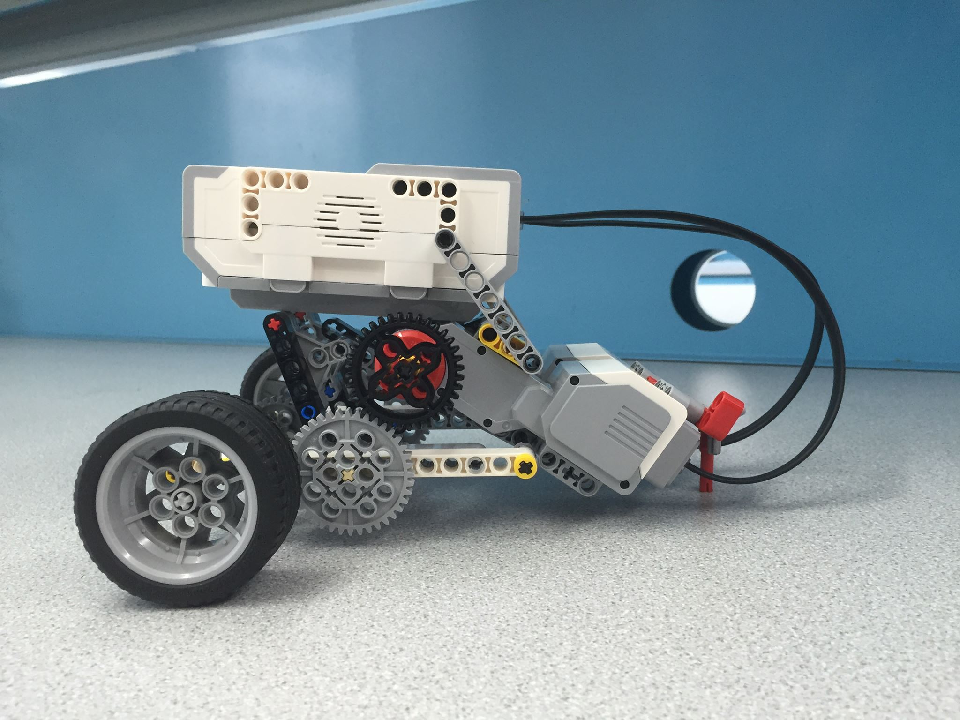

*Fig. 2: Modified robot design*

The modified robot was then tested. In the first trial, the robot’s measured distance traveled was 28.3cm, with an angle differential of 372 degrees. In the second trial, the measured distance traveled was 166.5cm, with an angle differential of 349 degrees, as seen in Figure 3.

|  |  |  |  |  |  |  |
| --- | --- | --- | --- | --- | --- | --- |
| New Design | Accuracy | %*Acc* | Pass/Fail | Precision | %*Prec* | Pass/Fail |
| Distance Test | 50.28 | 65.95% | Fail | 138.20 | 0.0001465% | Fail |
| Angle of Deviation Test | 0.5 | 99.86% | Pass | 23 | 47.57% | Fail |

*Fig. 3: Test data for the modified robot*

After the second trial concluded, the time allotted for the lab ran out, and so further testing for the modified robot could not be done.

**Discussion/Conclusions**

The original robot did not move, but ended up passing three of the tests, due to a quirk of how accuracy and precision are calculated. The modified robot, on the other hand, could move, but was still erratic in its path, resulting in a failure in most tests. However, in this scenario, it is a good reminder that both accuracy and precision are important metrics, which need to be given in context.

Even though the original robot passed most of its test, because it did not move, it thus failed to complete its primary objective of moving from point A to point B. Thus, it is recommended for the modified robot to be placed into production, since a product that works but is imperfect beats out a product that does not work that is near perfect.

An important thing to note about this lab was that due to email, server and other technical failures, the lab time allotted was nearly truncated by a third, resulting in the rush to modify the design, and to begin testing as soon as possible. This resulted in only two tests performed on the modified robot, resulting in a smaller data set that conclusions could be drawn from.

The robot could possibly be improved by changing the design of the gear meshes so that it would not be dependent on a weighted design in order to have the gear teeth sit flush next to one another. This would allow the robot to have freedom of motion, without being dependent on the weight of the gears itself to allow the robot to move.

**Works Cited**

NYU Polytechnic School of Engineering Faculty. “EG 1003 Lab Manual”.

*NYU Engineering Department*. January 22, 2015.

<https://manual.eg.poly.edu/index.php/Mousetrap_Vehicle_Competition>

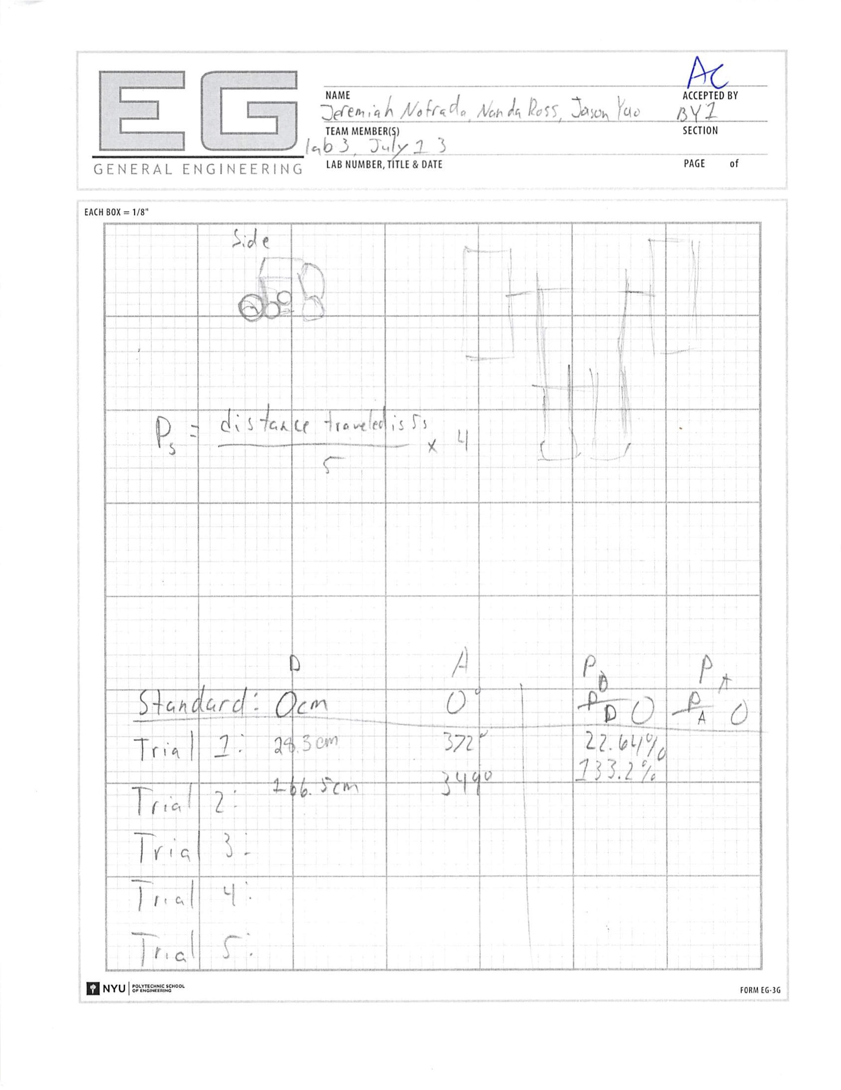

*Fig. 4: Initial design sketch*